

PROJECT REPORT
Group Members:
Muhammad Zayaan Amjad 65427
Syed Muhammad Bilal 58514
Submitted to: Sir Rizwan Ahmed

TOPIC : AI Treasure Hunt
Using BFS, DFS and A* Search

1. Introduction
AI Treasure Hunt is a desktop pathfinding application built in Python. It generates a random, guaranteed-solvable maze and then runs three classic search algorithms — Breadth-First Search (BFS), Depth-First Search (DFS), and A* Search — to locate a treasure placed inside the maze. The application animates the search process, records performance metrics for each algorithm, and can export everything into a formatted PDF report.
The purpose of the project is educational: BFS, DFS, and A* are usually taught with static diagrams. This tool makes their differences visible by letting the same maze be solved by all three algorithms and comparing the results directly.

1.1 Objectives
- Generate random, guaranteed-solvable mazes of configurable size.
- Implement BFS, DFS, and A* search using the correct underlying data structures (queue, stack, priority queue).
- Animate the cells explored by each algorithm and highlight the final route.
- Measure and compare path length, number of explored nodes, and execution time.
- Automatically select and explain the best-performing algorithm.
- Export the maze, paths, metrics table, and charts as a PDF report.

2. System Architecture
The application is organized into independent modules so that maze logic, search logic, the graphical interface, and reporting can each be tested separately:
- SearchResult — a small data class that stores one algorithm's output (path, visited order, execution time) and derives path length / explored node count.
- MazeGenerator — builds a random maze using recursive backtracking and adds optional loops.
- SearchAlgorithms — implements BFS, DFS, and A* on the generated maze.
- PDFReportExporter — turns the maze, paths, and metrics into a multi-page PDF using Matplotlib (for images/charts) and ReportLab (for PDF layout).
- TreasureHuntApp — the Tkinter GUI that ties everything together: controls, canvas, animation, and buttons.

3. Maze Generation
The maze is stored as a 2D grid where 1 represents a wall and 0 represents an open cell. Recursive backtracking is used: starting from the top-left cell, the algorithm repeatedly jumps two cells at a time into an unvisited neighbour, carving a passage through the wall in between, and backtracks (using a stack) when a cell has no unvisited neighbours left. This guarantees the maze is a "perfect maze" — there is exactly one path between any two cells, so it is always solvable.
After the perfect maze is built, a small percentage of extra interior walls are removed (extra_openings parameter) to create loops. This means there can be more than one valid route between the start and the treasure, which is what makes DFS's path length interesting to compare against BFS/A*. The outer border always stays closed.
class MazeGenerator:
@staticmethod
def generate(rows, columns, extra_openings=0.05, random_goal=False):
grid = [[1 for _ in range(columns)] for _ in range(rows)]
start = (1, 1)
goal = (rows - 2, columns - 2)
stack = [start]
grid[start[0]][start[1]] = 0

while stack:
row, column = stack[-1]
candidates = []
for dr, dc in ((-2,0),(2,0),(0,-2),(0,2)):
nr, nc = row+dr, column+dc
if 1<=nr<rows-1 and 1<=nc<columns-1 and grid[nr][nc]==1:
wall = (row+dr//2, column+dc//2)
candidates.append(((nr,nc), wall))
if not candidates:
stack.pop()
continue
(nr,nc),(wr,wc) = random.choice(candidates)
grid[wr][wc] = 0
grid[nr][nc] = 0
stack.append((nr,nc))

MazeGenerator._add_loops(grid, extra_openings)
return grid, start, goal

4. Search Algorithms
All three algorithms operate on the same maze and the same neighbour function (up, right, down, left — only into open cells). Each returns a SearchResult containing the reconstructed path, the order in which cells were visited, and the execution time in milliseconds.

4.1 Breadth-First Search (BFS)
BFS uses a FIFO queue (collections.deque) and explores the maze level by level — all cells at distance 1 from the start, then all cells at distance 2, and so on. Because every move costs the same (1 step), the first time BFS reaches the goal it is guaranteed to be via the shortest possible path.
def bfs(self):
queue = deque([self.start])
discovered = {self.start}
parent = {self.start: None}
visited_order = []

while queue:
current = queue.popleft()
visited_order.append(current)
if current == self.goal:
break
for neighbor in self.neighbors(current):
if neighbor not in discovered:
discovered.add(neighbor)
parent[neighbor] = current
queue.append(neighbor)

return SearchResult('BFS', self.reconstruct_path(parent, self.goal),
visited_order, elapsed_ms)

4.2 Depth-First Search (DFS)
DFS uses a LIFO stack and dives deep along one branch before backtracking. It will eventually find the goal (since the maze is solvable) but the route it finds depends entirely on which branch it happened to explore first — it is not guaranteed to be the shortest.
def dfs(self):
stack = [self.start]
discovered = {self.start}
parent = {self.start: None}
visited_order = []

while stack:
current = stack.pop()
visited_order.append(current)
if current == self.goal:
break
for neighbor in reversed(list(self.neighbors(current))):
if neighbor not in discovered:
discovered.add(neighbor)
parent[neighbor] = current
stack.append(neighbor)

return SearchResult('DFS', self.reconstruct_path(parent, self.goal),
visited_order, elapsed_ms)

4.3 A* Search
A* uses a priority queue (Python's heapq) ordered by f(n) = g(n) + h(n), where g(n) is the actual number of steps taken so far and h(n) is the Manhattan distance heuristic — the straight-line grid distance to the goal ignoring walls. Because Manhattan distance never overestimates the true remaining cost in a 4-directional grid, it is an admissible heuristic, which is why A* is guaranteed to still find the shortest path, just like BFS — but it usually explores far fewer cells because the heuristic actively steers the search toward the goal instead of expanding equally in every direction.
def a_star(self):
counter = 0
open_heap = [(self.heuristic(self.start), counter, self.start)]
parent = {self.start: None}
g_score = {self.start: 0}
closed = set()
visited_order = []

while open_heap:
_, _, current = heapq.heappop(open_heap)
if current in closed:
continue
closed.add(current)
visited_order.append(current)
if current == self.goal:
break
for neighbor in self.neighbors(current):
tentative_g = g_score[current] + 1
if tentative_g < g_score.get(neighbor, 10**18):
g_score[neighbor] = tentative_g
parent[neighbor] = current
counter += 1
f_score = tentative_g + self.heuristic(neighbor)
heapq.heappush(open_heap, (f_score, counter, neighbor))

return SearchResult('A*', self.reconstruct_path(parent, self.goal),
visited_order, elapsed_ms)

def heuristic(self, position):
return abs(position[0]-self.goal[0]) + abs(position[1]-self.goal[1])

4.4 Path Reconstruction
All three algorithms use the same technique to recover the final path: whenever a cell is discovered, its parent (the cell we came from) is recorded in a dictionary. Once the goal is reached, we simply walk backwards through parent[] until we reach None (the start), then reverse the list.
@staticmethod
def reconstruct_path(parent, goal):
if goal not in parent:
return []
path = []
current = goal
while current is not None:
path.append(current)
current = parent[current]
path.reverse()
return path

5. Best-Algorithm Selection Logic
After all three algorithms run, the application automatically selects the "best" result using a priority order, and shows the reason in the UI, the status bar, and the PDF report:
- 1. The algorithm must have actually found the treasure.
- 2. Among those that found it, a shorter path length wins.
- 3. If path length is tied, fewer explored nodes wins.
- 4. If that is also tied, lower execution time wins.
This is implemented with Python's min() and a tuple key, which compares each criterion in order automatically:
found_results = [r for r in results if r.found]
best = min(
found_results,
key=lambda r: (r.path_length, r.explored_nodes, r.execution_ms),
)

6. Sample Run and Results
The following results were produced by running the application's own code on a randomly generated 21×21 maze (fixed random seed for reproducibility):
Algorithm | Treasure Found | Path Length | Explored Nodes | Time (ms)
BFS | Yes | 40 | 220 | 0.4111
DFS | Yes | 74 | 75 | 0.1868
A* | Yes | 40 | 82 | 0.2757

Observations:
- BFS and A* both returned a path of 40 moves — the shortest possible route in this maze — confirming that A* is optimal here.
- A* explored only 82 cells versus BFS's 220 cells, i.e. roughly 63% fewer nodes, because the Manhattan-distance heuristic steered it toward the goal instead of expanding uniformly in all directions.
- DFS found a valid path (74 moves) with very few explored nodes (75) and the fastest time, but its path is almost twice as long as the optimal route — illustrating that DFS is fast and memory-light but not shortest-path-optimal.
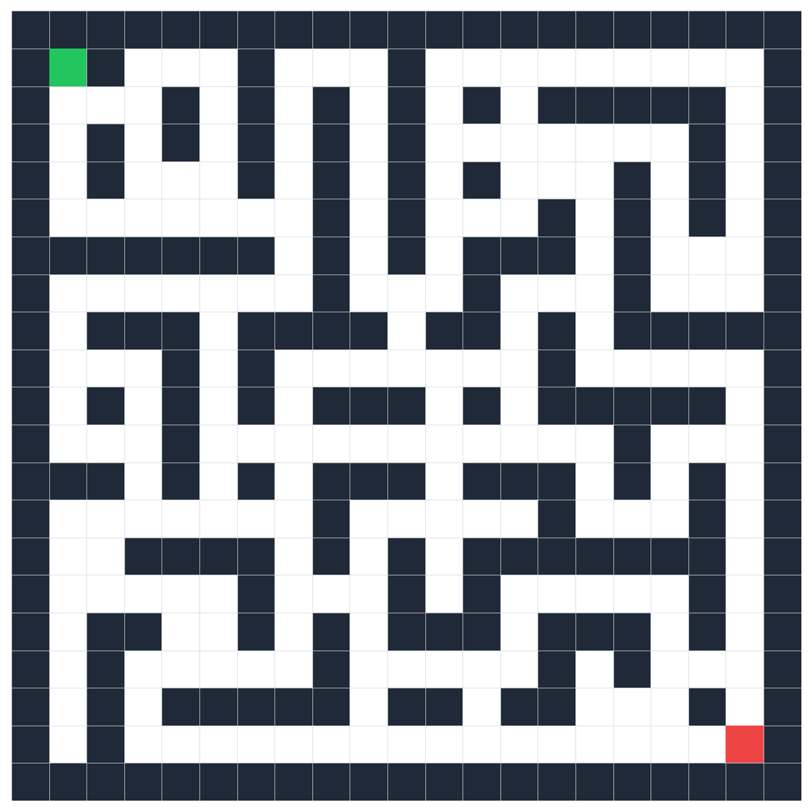
Figure 1: Generated maze — green = start, red = treasure, dark cells = walls.
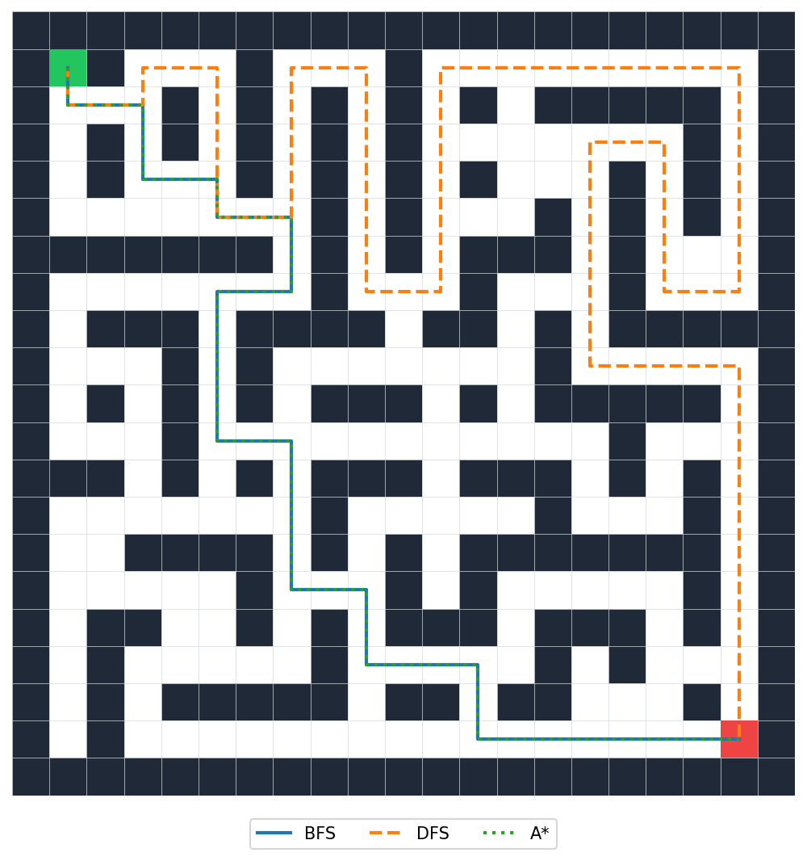
Figure 2: Final routes found by BFS, DFS, and A* overlaid on the same maze.
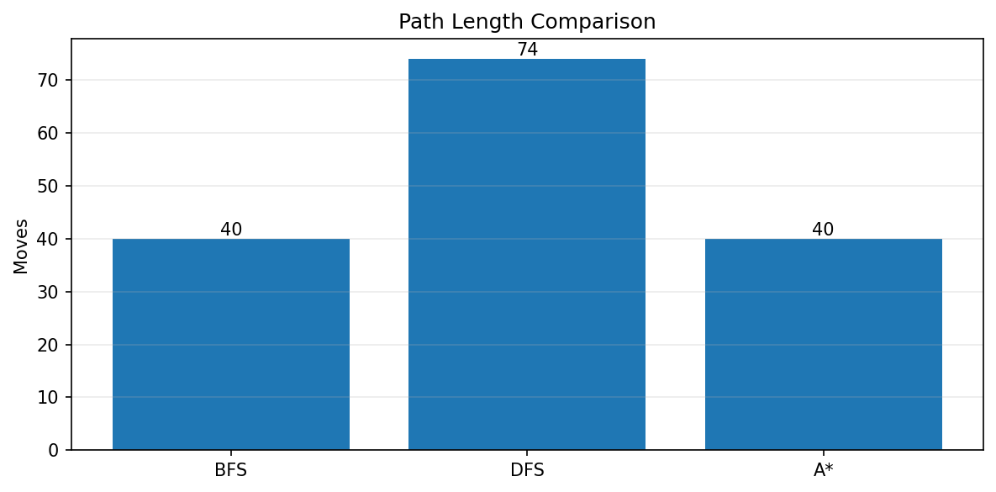
Figure 3: Path length comparison — BFS and A* tie for shortest; DFS is longer.
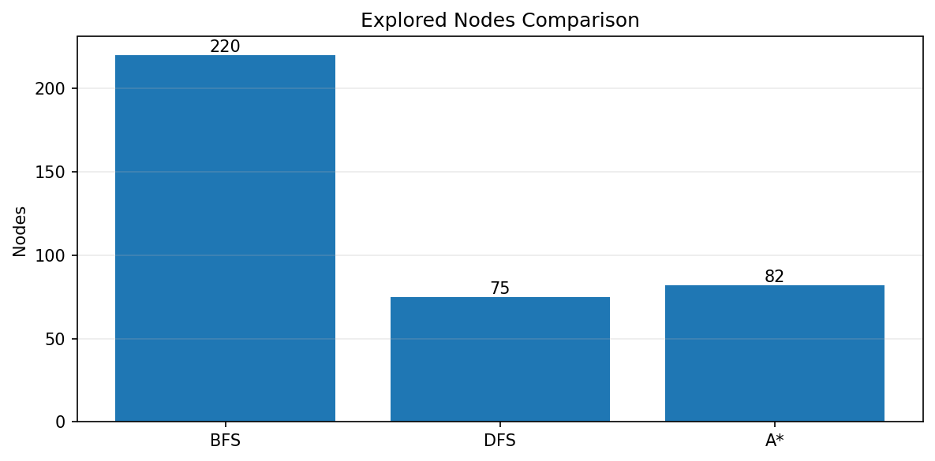
Figure 4: Explored-nodes comparison — A* explores far fewer cells than BFS.
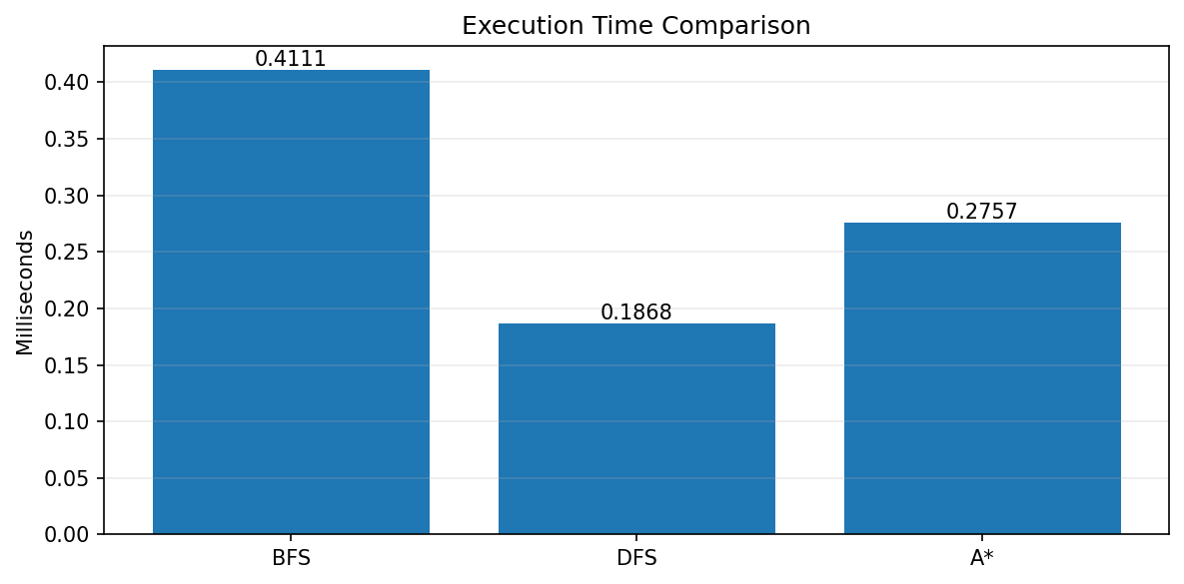
Figure 5: Execution time comparison (milliseconds).

7. PDF Report Generation
The PDFReportExporter class uses Matplotlib to render the maze, the overlaid solution paths, and three bar charts as PNG images, then assembles them with ReportLab's Platypus layout engine (SimpleDocTemplate + Paragraph/Table/Image flowables) into a multi-page PDF: a title section, a "Best Result" table, a full metrics table, the maze image, the paths image, and the three comparison charts, each on its own page.
document = SimpleDocTemplate(output_path, pagesize=A4, ...)
story = [
Paragraph('AI Treasure Hunt - BFS, DFS and A*', styles['Title']),
... best-result table ...,
... metrics table ...,
Image(maze_image, width=maze_width, height=maze_height),
PageBreak(),
Image(path_image, ...), PageBreak(),
Image(path_length_chart, ...),
Image(explored_chart, ...), PageBreak(),
Image(execution_chart, ...),
]
document.build(story, onFirstPage=_draw_footer, onLaterPages=_draw_footer)

8. Time and Space Complexity
Let V be the number of open cells (states) and E the number of edges (adjacent open-cell pairs, each cell has at most 4 neighbours).
- BFS: Time O(V + E), Space O(V) — every reachable cell is visited once and stored in the queue/visited set.
- DFS: Time O(V + E), Space O(V) — same asymptotic bound as BFS, but the stack only ever holds one active path plus backtrack points, so it is often lighter in practice.
- A*: Time O(E · log V) in the worst case because of the heap operations, Space O(V) — in practice it visits far fewer than V cells when the heuristic is informative, as shown in the results above.

10. Conclusion
The AI Treasure Hunt project successfully demonstrates and compares three fundamental search strategies on identical, randomly generated mazes. The results consistently match the theory: BFS and A* both guarantee the shortest path, A* does so while exploring substantially fewer nodes thanks to its heuristic, and DFS is fast but not path-optimal. The modular design (separate maze generation, search, GUI, and reporting components) keeps the code easy to test, extend, and explain.

